**Electronic supplementary information**

**FAST MOTIONS OF AN IRIDIUM DIHYDRIDE COMPLEX  
IN AN AQUEOUS MEDIUM REVEALED BY  
NMR RELAXOMETRY WITH HIGH-RESOLUTION**

A. S. Kiryutin,* N. N. Fishman, and A. V. Yurkovskaya

*International Tomography Center, Siberian Branch of the Russian Academy of  
Sciences, ul. Institutskaya 3A, Novosibirsk, 630090 Russia*

**Table of contents**

|  |  |
| --- | --- |
| **1. Sample preparation** | S2 |
| **2. Long-term stability of the complex in an aqueous solution** | S4 |
| **3. 13C–1H HSQC NMR spectrum** | S5 |
| **4. Variable-temperature 1H NMR spectra** | S7 |
| **5. SABRE spectrum** | S8 |
| **6. DOSY spectrum** | S9 |
| **References** | S9 |

**1. Sample preparation**

It is known that the precatalyst is not soluble in water but is well soluble in pyridine, so the following method was used to obtain an aqueous solution of the iridium hydride. To a small amount of the precatalyst (1.1 mg), 6 µL of pyridine (approximately 6 µg) was added. Even in this small amount of pyridine, a yellow powder dissolved to form a yellow clear solution. Then water was added portionwise: first 31 µL of D2O, then 589 µL of deionized H2O in portions of about 100 µL. After addition of each water aliquot, the solution was stirred in the tube. The resulting turbid solution (Fig. S1, left) was placed in a 5 mm screw cap NMR tube for gas bubbling. Using a custom-made adapter with a capillary for the NMR sample tube, the solution was bubbled with argon for 5 min to remove dissolved air, then the solution was bubbled with hydrogen at 4 atm for 15 min at approximately 40–45 °C. An increase in the temperature was necessary to reduce the viscosity and surface tension of water, which allowed the solution to be bubbled in a narrow tube without the formation of a large amount of foam. As the solution was bubbled with hydrogen, it lost its yellow color and became colorless and transparent (Fig. S1, right). At the end of hydrogen bubbling, the NMR tube was depressurized, excess hydrogen was released, and the sample tube was closed with a cap and sealed with a tape to prevent air from entering the sample tube. Immediately after hydrogen bubbling, the solution was colorless but also slightly turbid. It is supposed that colloidal particles from cyclooctene and cyclooctane, which are the products of hydrogenation of cyclooctadiene, were formed in an aqueous solution. The solution was left overnight, after which it became transparent. All NMR spectra and relaxation experiments were recorded with the transparent solution for several days. The concentrations in the final solution were as follows: Py—120 mM, the iridium complex—1.5 mM, dissolved H2—less than 1 mM.

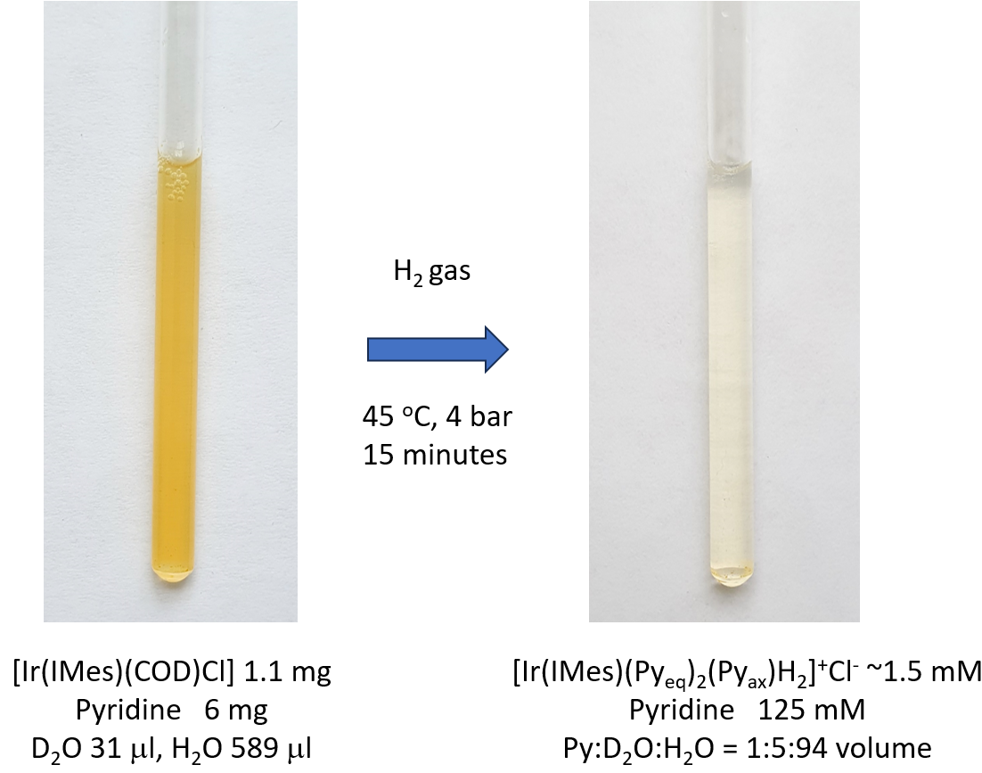

**Figure S1**. Photographs of the solution before (left) and after (right) bubbling with hydrogen.

The maximal calculated concentration of the resulting complex hydride should be 2.7 mM, but, during dissolution in water, a yellow precipitate was visible on the walls of the test tube, so the real concentration of the complex was lower than the calculated one. We calculated the concentration of the complex from the NMR spectrum compared to the signal of free pyridine, it was 1.5 mM.

Figure S2 shows the 1H NMR spectra taken before and after hydrogen bubbling. As can be seen, the spectrum before hydrogen bubbling shows the pyridine signals. Apparently, it is pyridine coordinated to iridium even before activation. This can explain the dissolution of the precatalyst in water. After the reaction with hydrogen, a characteristic hydride signal at –22.9 ppm and the disappearance of the signals of coordinated cyclooctadiene were observed.

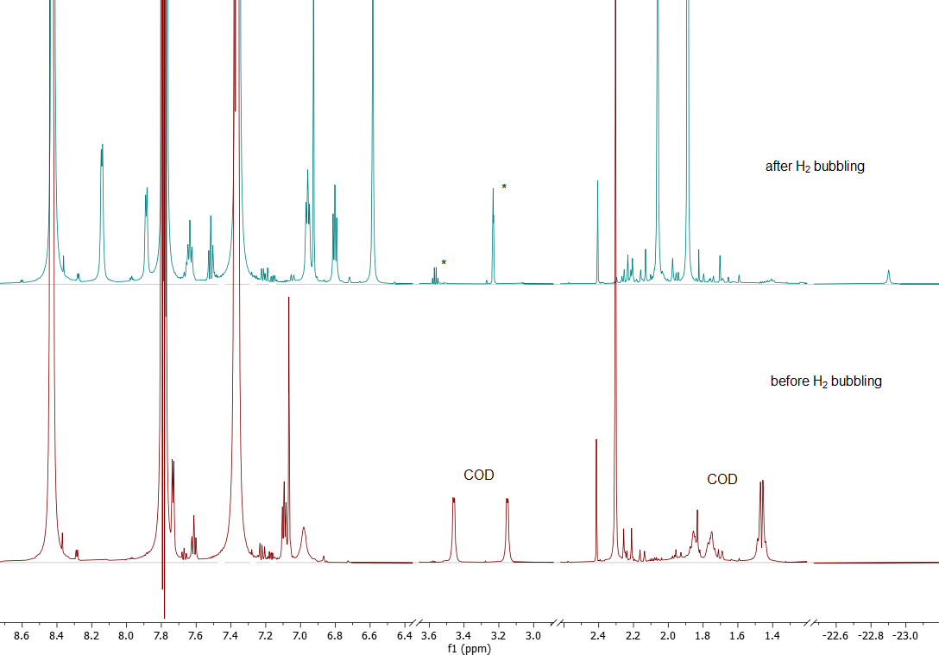

**Figure S2**. 700 MHz 1H NMR spectra of precatalyst [Ir(IMes)(COD)Cl] (COD—cyclooctadiene) in an aqueous solution in the presence of pyridine before H2 bubbling and after reaction with H2. The temperature was 25 °C. Asterisks indicate traces of ethanol and methanol-d4, coming from the bubbling apparatus.

**2. Long-term stability of the complex in an aqueous solution**

It was found that the iridium dihydride complex is quite stable in an aqueous solution, which made it possible to measure its T1 relaxation times in a wide range of magnetic fields, as well as to obtain two-dimensional spectra and carry out signal assignment. Figure S3 shows the 700 MHz 1H NMR spectra measured at different times after the sample preparation. They show how long the original complex exists in solution and how it transforms in time. We have integrated the main signals of the complex and plotted the time dependence of the signal intensity on Fig. S4. Fitting with a decreasing exponential function allowed us to determine the effective lifetime (114 h or 4.75 days) of the complex in an aqueous solution at room temperature.



**Figure S3**. 700 MHz 1H NMR spectra of complex [Ir(IMes)(Pyeq)2(Pyax)H2]Cl in an aqueous solution obtained at different times after the sample preparation. Asterisks indicate the signals related to the decomposition products of the complex.



**Figure S4**. Time dependence of the proton signal intensity of [Ir(IMes)(Pyeq)2(Pyax)H2]Cl. The data were obtained by integrating the spectra from Fig. S3. The solid lines are the results of fitting with a passing exponent with a common decay time.

**3. 13C–1H HSQC NMR spectrum**

To assign the 13C resonances of the ligands in the dihydride complex, the HSQC NMR spectrum was obtained on a 16.4 Tesla 700 MHz instrument at 25 °C. Figures S5 and S6 show the aromatic and aliphatic parts of the whole spectrum. The signal assignments of the compound under investigation are shown on the spectra. It should be noted that the spectrum was recorded in several days after the sample preparation and according to Fig. S3, the new signals appeared in solution, which relate to the decomposition or transformation products of the main complex. These signals are not assigned on the HSQC spectra as they are not the object of this study.

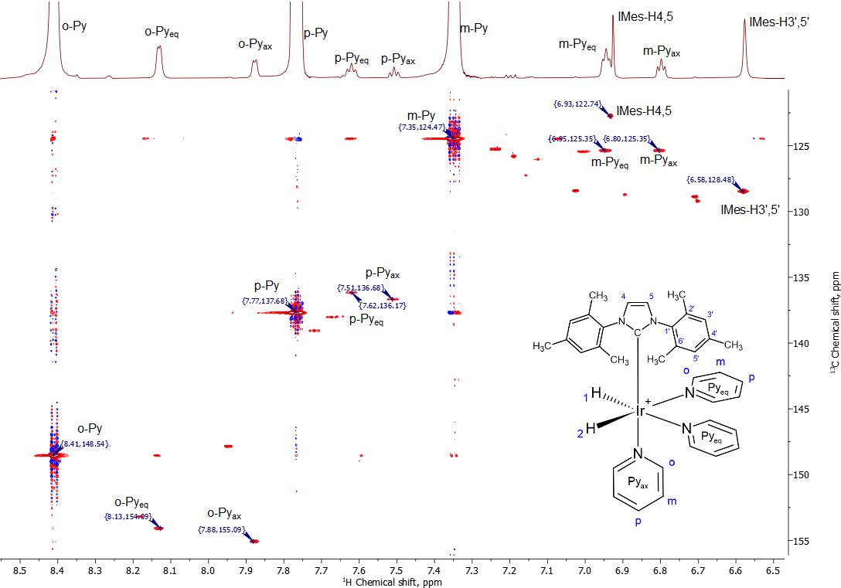

**Figure S5**. Aromatic part of the 13C–1H HSQC NMR spectrum registered on a 700 MHz spectrometer. Molecular structure, atom numbering, and assignments of the main signals are shown on the figure. The temperature was 25 °C.



**Figure S6**. Aliphatic part of the 13C–1H HSQC NMR spectrum registered on a 700 MHz spectrometer. Molecular structure, atom numbering, and assignments of the main signals are shown on the figure. The temperature was 25 °C.

**Table S1.** Chemical shifts of complex [Ir(IMes)(Pyeq)2(Pyax)H2]Cl in an aqueous solution at 25 °C

|  |  |  |
| --- | --- | --- |
| Nuclei, atom position | 1H chemical shift, ppm | 13C chemical shift, ppm |
| Ir-HH | –22.9 | – |
| IMes-CH3-H2',6' | 1.88 | 17.85 |
| IMes-CH3-H4' | 2.06 | 19.94 |
| IMes-H3',5' | 6.58 | 128.48 |
| IMes-H4,5 | 6.93 | 122.74 |
| o-Py(axial) | 7.77 | 137.68 |
| p-Py(axial) | 7.51 | 136.68 |
| m-Py(axial) | 6.80 | 125.35 |
| o-Py(equatorial) | 8.13 | 154.09 |
| p-Py(equatorial) | 7.62 | 136.17 |
| m-Py(equatorial) | 6.95 | 125.35 |
| o-Py(free) | 8.41 | 148.54 |
| p-Py(free) | 7.77 | 137.68 |
| m-Py(free) | 7.35 | 124.47 |

**4. Variable-temperature 1H NMR spectra**

Figure S7 shows the 1H NMR spectra of the iridium dihydride complex in an aqueous solution, more specifically in a mixed solvent containing pyridine/D2O/H2O in a volume ratio of 4:8:88. With decreasing temperature, the narrowing of the Ir-HH signals as well as the equatorial pyridine protons is observed. As the temperature increases, these signals broaden and then disappear. At the same time, the proton signals of the axial pyridine ligand are practically independent of temperature, indicating very strong binding of pyridine at the axial position. A sequence with weak pre-saturation of water protons and with suppression of 13C spin–spin interactions during FID accumulation was used to record the spectra in H2O.

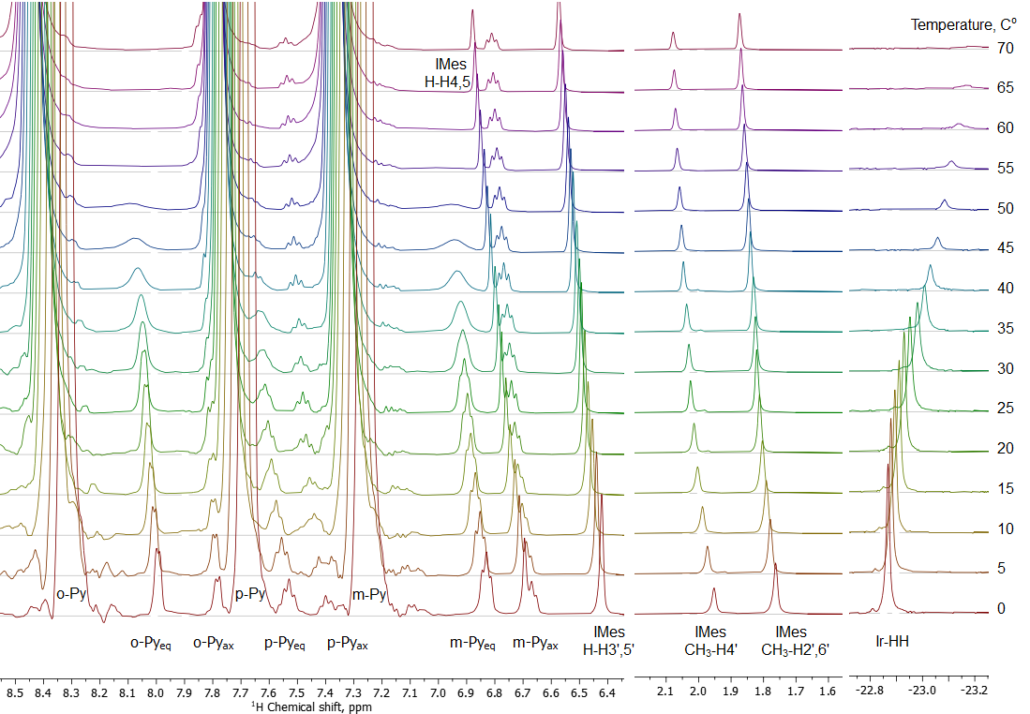

**Figure S7**. 400 MHz 1H NMR spectra of [Ir(IMes)(Pyeq)2(Pyax)H2]Cl in a mixed solvent Py/D2O/H2O = 4:8:88 (volume) measured at different temperature from 0 to 70 °C. Assignments are shown along the signals. To calibrate the chemical shifts at different temperatures, we used the signal of water, the chemical shift of which depends on the temperature according to the known formula *δ*(H2O) = 7.83–T/96.9. The concentration of pyridine was 520 mM, the concentration of [Ir(IMes)(Pyeq)2(Pyax)H2]Cl was about 4 mM.

**5. SABRE spectrum**

For the SABRE experiment, a sample containing 1.5 mg of the precatalyst, 25 μL of pyridine, 50 μL of D2O, and 525 μL of H2O was prepared; the pH value of the sample was 8.7. For activation, the solution was bubbled with hydrogen at 4 atm and 45 °C for 10–15 min, until complete hydrogenation of cyclooctadiene and formation of the stable iridium dihydride. The SABRE experiment was then carried out in an ultra-weak magnetic field setup. The details can be found in Ref. 1. Figure S8 shows the 15N SABRE NMR spectrum after bubbling the sample with parahydrogen gas (about 95% of para-H2) in a 0.5 μT magnetic field for 5 s followed by moving the sample into a 9.4 Tesla detection field (400 MHz spectrometer). The spectrum was registered from a single scan using proton suppression. Note that the spectrum was obtained at the natural abundance of the 15N isotope. The approximate amplification factor in comparison with the thermal polarization level is 10000 times, which is 3.5% of the polarization in absolute value.



**Figure S8**. 15N{1H} SABRE NMR spectrum (40.6 MHz) recorded for the sample containing 25 mL of pyridine with iridium dihydride [Ir(IMes)(Pyeq)2(Pyax)H2]Cl as a SABRE catalyst in an aqueous solution at 35 °C. The polarization field equals to 0.5 mT, bubbling with parahydrogen during 5 s at 4 atm.

**6. DOSY spectrum**

In order to verify that there is one single complex in solution, we performed a DOSY experiment, which allowed us to separate the signals according to the diffusion coefficients of molecules in solution. Figure S9 shows the DOSY spectrum, in which all the lines attributed to the iridium complex are located on the same horizontal line, confirming that the signals are from a single molecule. The spectrum also shows the signals of pyridine and water, which have lower diffusion coefficients, as well as a singlet peak with a chemical shift of 2.5 ppm, which has a diffusion coefficient similar to that of pyridine.

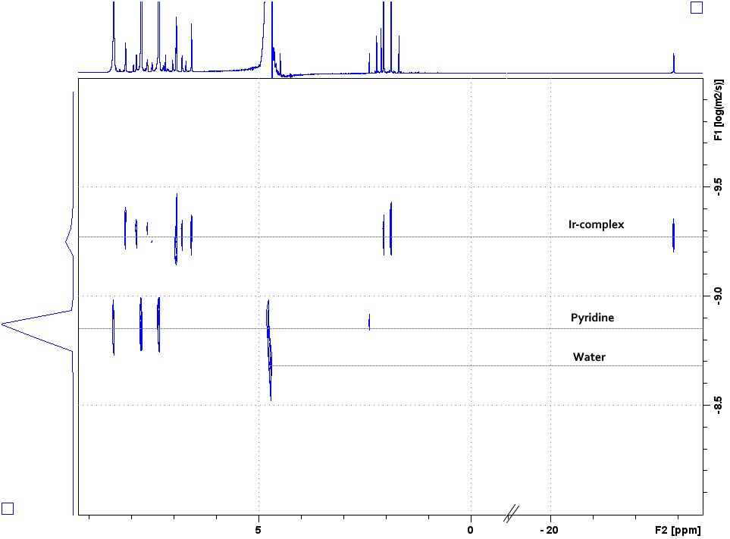

**Figure S9**. 1H DOSY NMR spectrum of the sample containing iridium dihydride [Ir(IMes)(Pyeq)2(Pyax)H2]Cl in an aqueous solution at 25 °C.

**References**

1. A. S. Kiryutin, A. V. Yurkovskaya, H. Zimmermann, H.-M. Vieth, K. L. Ivanov, *Magn. Reson. Chem.*,**2018**, *56*, 651–662. DOI: 10.1002/mrc.4694